**8th Annual AOGIN India Conference 2017 - Report**

**The 8th Annual AOGIN India 2017 Conference** was held from **8th to 10th Sept 2017** at **Hotel Clarks Avadh, Lucknow**. It was organized by the AOGIN india members of Lucknow with Department of Obstetrics and Gynecology, King George Medical University and members of Lucknow Obstetrics and Gynecology Society. Prof HP Gupta was the Organizing Chairperson and Prof Nisha Singh was the Organizing Secretary of the conference**.** The conference was attended by 300 Indian and 30 overseas delegates.

**CONFERENCE INAUGURATION** – Inauguration function was held on 8th September 2017. **Shri Brijesh Pathak**, Minister for Law and Justice, Uttar Pradesh was the Chief Guest. **Prof MLB Bhatt**, Vice Chancellor of King George’s Medical University and **Sri SS Upadhyaya**, Legal Advisor to the Governor of Uttar Pradesh were the Guests of Honor. After the lamp lightening, founder president **Dr Neerja Bhatla** appraised the gathering about the formation of AOGIN India organization, **Dr Shalini Rajaram** gave the Presidential Address and Hon Secretary, **Dr Rupinder Sekhon** presented the Annual report. The print issue of AOGIN India newsletter (**Editor, Prof Nisha Singh**) was also released by the Chief Guest. The Chief guest and Guests of Honour congratulated the organizers and gave their blessings. The organizing team felicitated the dignitaries. The organizing secretary Dr. Nisha Singh proposed the Vote of Thanks to one and all involved in the conference.

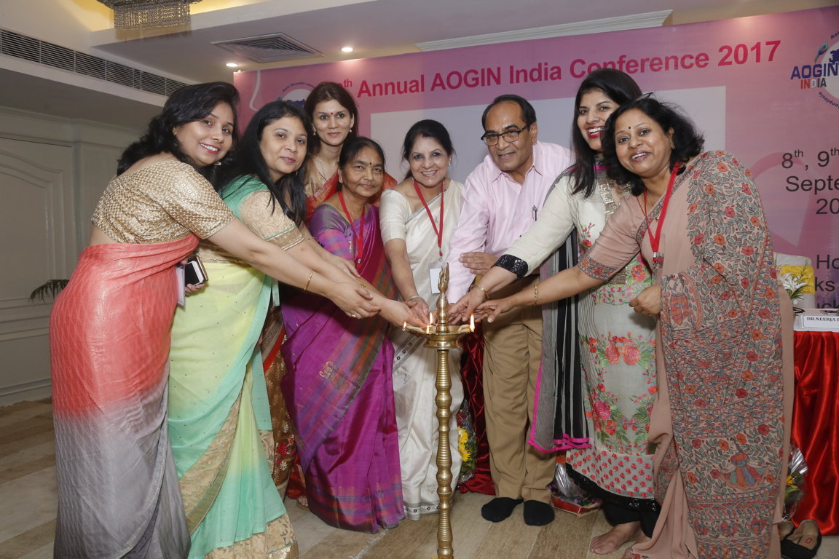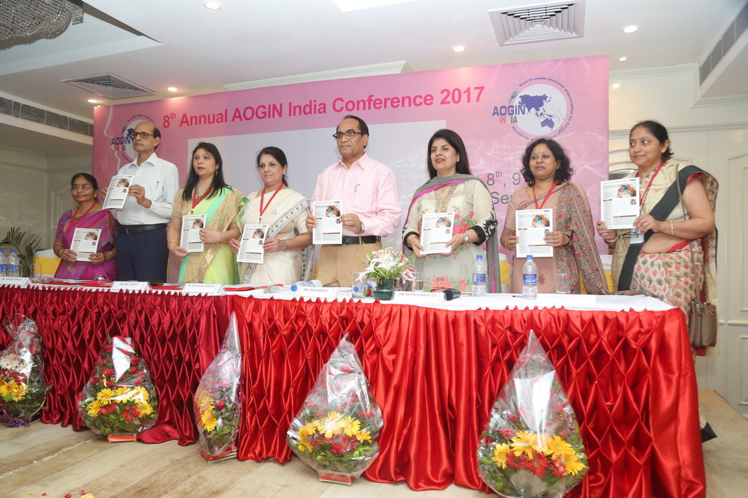

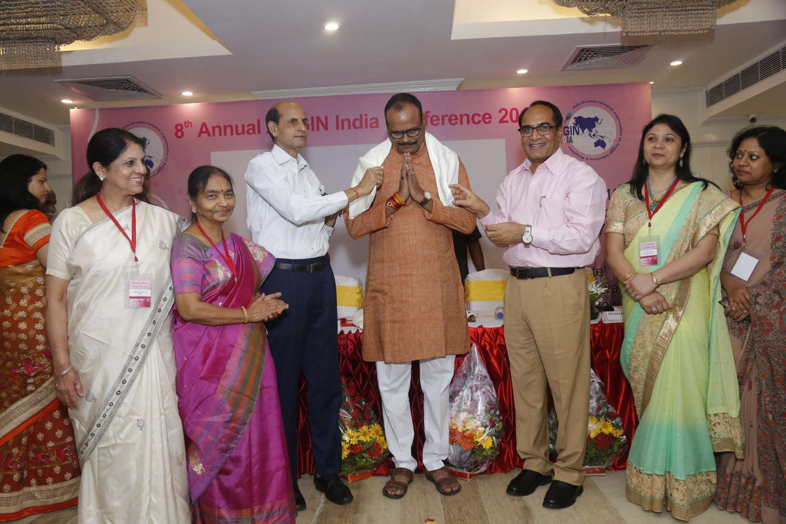

The conference started with **Five workshops** held on 8th September. In three halls of Hotel Clarks Avadh. The details are as follows:

**1. Colposcopy, Crytherapy and LEEP Workshop (8th September 2017 Hall 1, 9am-1:00pm)**

The first session titled “Introduction to colposcopy was chaired by **Dr Partha Basu** from IARC and Dr Manju Shukla. Dr Shweta Balani from New Delhi talked about “New insights in Pathogenesis of CIN. Dr Gitanjali Amin from Mumbai discussed about Equipment and indications of Colposcopy and Dr Kavita N. Singh from Jabalpur presented and discussed a Video on Procedure of Colposcopy.

**Dr Dipanwita Banerjee** presented a variety of cases of Colposcopy through demonstration of colposcopic picture and vedios, which were discussed by national experts including Dr Neerja Bhatla, Dr Shalini Rajaram, Dr Maya Lulla and Dr Sudha Nigam.

The session on “Treatment of CIN” was chaired by Dr Shalini Rajaram and Dr Anjoo Agrawal where videos on Ablative and excisional Methods were shown by Dr Uma Singh (Cryotherapy) and Dr S.K. Giri (Conization).

Dr Dipanwita Bannerjee and Dr Amrit Gupta gave hands on LEEP training in small groups.

**2. Community Screening Workshop (8th September 2017 Hall 1, 2:00-5:00 pm)**

This workshop was attended by **160 urban ASHA workers of Lucknow** who actively participated and learnt about screening of their role in screening and prevention of cervical and breast cancer. Dr Amresh Bahadur Singh from the NHM, Uttar Pradesh helped in providing this opportunity to the ASHA workers. **Prof. Enriquito Lu’s team from JHPIEGO** and national faculty particularly **Dr Srabani Mittal** helped in coordinating this workshop.

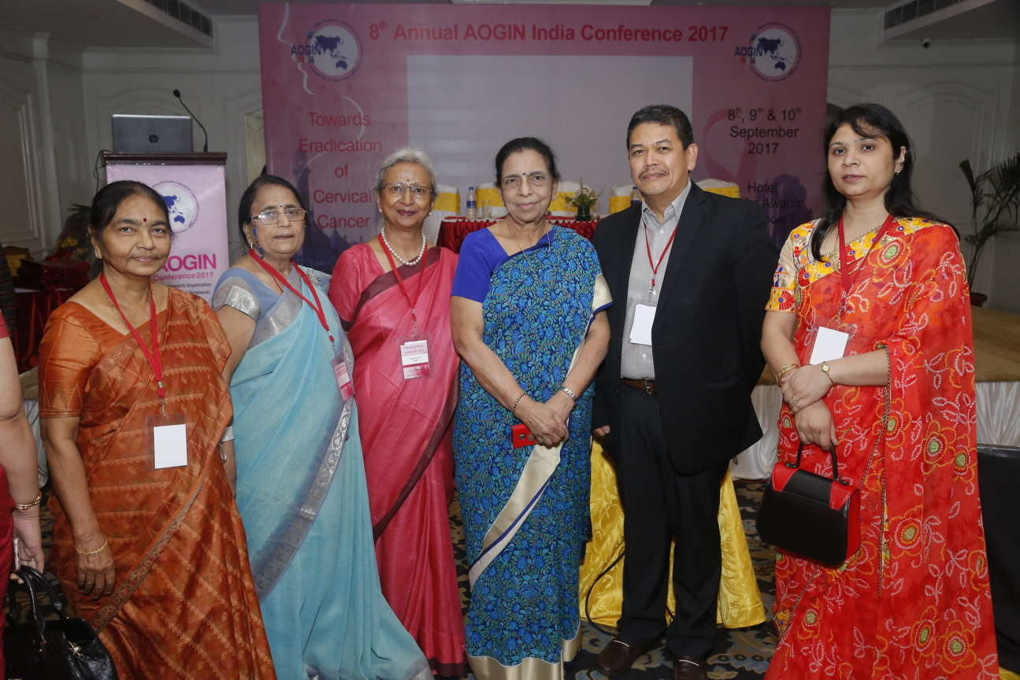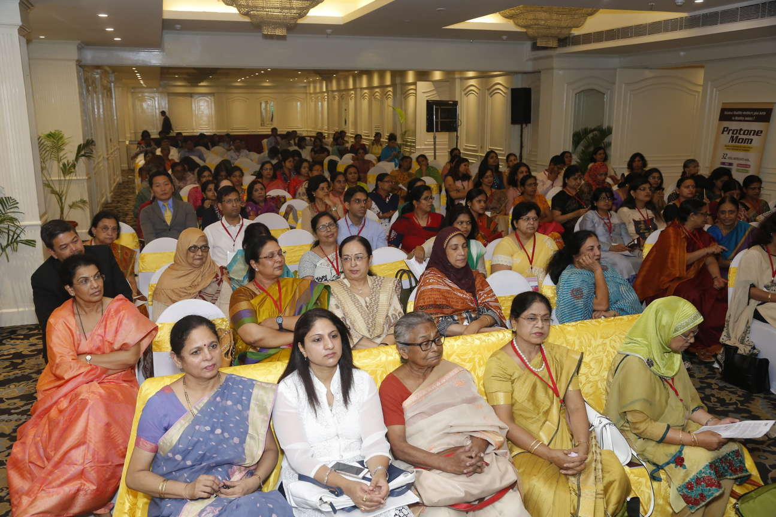

The first session entitled “Introduction to common cancers of women, risk factors and Symptoms” was chaired by **Prof. Enriquito Lu’s** and Dr Saroj Srivastava. Dr Bindiya Gupta gave a talk was on Cervical Cancer and Dr Ruchi Pathak on Breast Cancer. Dr Geeta Chibber appraised the ASHAs about National guidelines of NCD Focusing on cancer and role of ASHA's in its prevention. Dr Srabani Mittal talked about Cervical Cancer prevention by screening and vaccination and Dr Amrita Chaurasiya about Breast cancer Prevention.

The second session on **Video Demonstration** was chaired by Dr Gita Khanna and Dr Deepa Kapoor. The first video was on Cervical sample collection techniques – PAP/HPV by Dr Srabani Mittal followed by videos on VIA and BSE by Dr Shikha Srivastava. Dr Rashmi Asif talked about “Counseling for screening of cervical and breast cancer”.

The Group activities included a Role play on counseling- conducted by ASHA workers under guidance of Dr. Rashmi Asif followed by a Debriefing by Dr Shikha Srivastava.

This was followed by a Quiz for Participants conducted by Dr Amrita Chaurasiya.

**3. Video Workshop on Surgical Management (8th September 2017 Hall 2, 9:00- 1:00 pm)**

The first session of video workshop was chaired by Dr. HP Gupta and Dr Indu Tandon. Dr. **Anupma Rajababu** from Kochi presented video on Sentinel LN mapping in cervical cancer. She answered all questions on this new technique **Dr. Shalini Rajaram** presented a talk on “Radical Hysterectomy – Classification and Indications. **Dr. Adeola Olaitan** from London presented detailed Video on Laproscopic Radical Hysterectomy, which was highly appreciated by the participants. Dr. Sabhyata Gupta presented Video on Robotic radical Hysterectomy showing the key differences in the robotic technique.

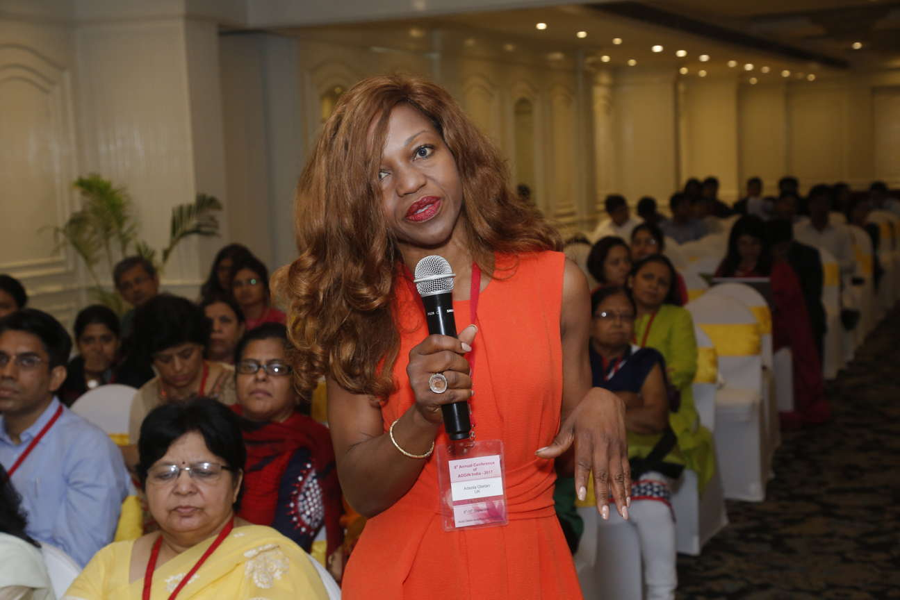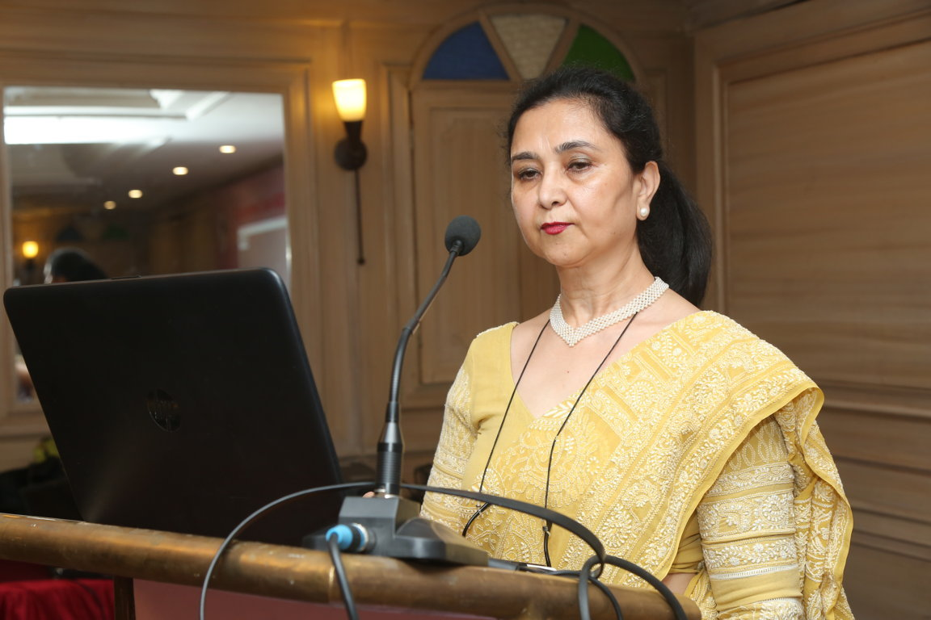

The next session was chaired by Dr. Vivek Garg and Dr. Shikha Seth.Video on Vulvectomy and Inguinofemoral lymphadenectomy for vulvar cancer was presented by AOGIN India Secretary, **Dr. Rupinder Sekhon** followed by a Video on parametrectomy by Dr Shveta Giri and a lecture on Benign Vulval lesions by Dr. Ragini Mehrotra.

**4. Cytopathology and HPV detection workshop (8th September 2017, 2:00-5:00pm)**

This workshop was organized for pathologists and gynecologists together. **Dr. Alok C Bharti**

presented a talk on “Basics of HPV infections cervical cytology and cervical carcinogenesis. **Dr. Sandeep Mathur** from AIIMS, New Delhi discussed Cervical Cytology methods and clarified the differences and advantages of liquid based cytology against Conventional cytology. The Demonstration of equipment and procedure was also done during the workshop.

**Dr. Suzanne Garland** from Australia presented her talk on “Cervical cytology in disease diagnosis and population screening: Changing strategies with changing goals. Dr. Madhumati Goel discussed the “Challenging areas of cervical cytology in KGMU”. Dr. Puneet Chandna discussed the importance of “Quality control in cytopathology “.

“Molecular methods of HPV testing in cervical scarpes: Option and oppurtunities” were discussed by Dr. Alok C Bharti. Dr. Priya Abraham talked about Importance of HPV co-testing with cervical cytology and reflex testing. There was an interactive Picture quiz for participants by Dr. Sandeep Mathur and Dr. Riddhi Jaiswal

**5. Training the Trainers Seminar for IFCPC-IARC Distance Learning Program (Hall3, 10:00am- 5:00pm)**

The second Training the Trainers Seminar for the IFCPC-IARC Distance Learning Program in Colposcopy was attended by 23 gynecologists who are faculty in various medical colleges. This included six gynecologists from Bangladesh and two from Mangolia. The program faculty included Dr Sankarnarayanan & Dr Partha Basu from IARC, Dr Theresa Wang & Dr Neerja Bhatla from IFCPC, and Dr Saritha Shamsunder, the India Co-ordinator.

The Seminar started with an outline of the Distance Learning Program, teaching the use of Colposcope, IFCPC 2011 terminology, teaching ablative methods and LLETZ, workplace based assessments and feedback. The feedback was very positive and the delegates were hopeful of taking on a trainee. The meeting ended with a vote of thanks from Dr Sweta Balani, the Joint coordinator to the Organizers of AOGIN 2017 for providing the space and support for hosting the meeting.

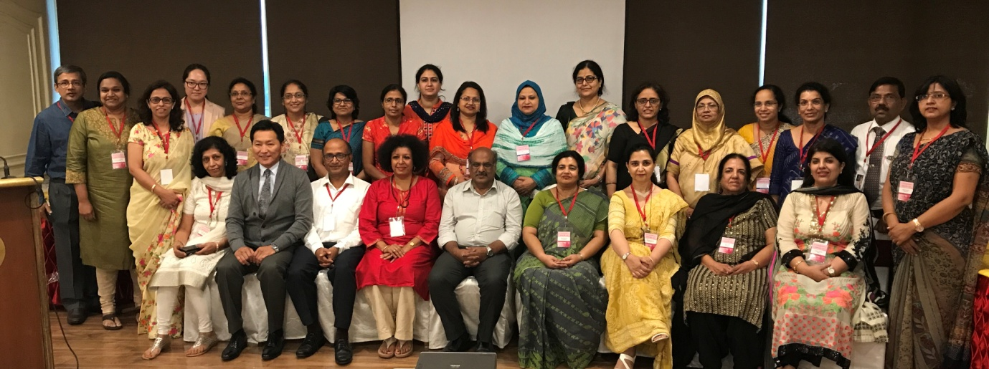

**Rally on Cervical cancer Awareness – 8th September 2017, 5:00-5:30pm**

All office bearers of AOGIN India including Dr Neerja Bhatla, Dr Shalini Rajaram, Dr Abraham Peedacayil, Dr Rupinder Sekhon and members of Organizing committee (Dr Nisha Singh, Dr Malvika Misra, Dr Shuchi Agrawal, Dr Vaishali Jain) collected at the gate of Hotel Clarks Awadh at 5pm. Along with many other faculty, delegates and ASHA workers, they participated in the **“Rally on Cervical cancer Awareness** that started from Hotel Clarks Awadh to DGHS Office and returned back to the hotel**.** Approximately 150 participants wearing AOGIN India caps marched enthusiastically shouting slogans of HPV vaccination and fight with cervical cancer. The colorful banners showed all benefits of HPV vaccination and screening for prevention of cervical cancer. The rally performance was made possible with the help of traffic police Lucknow.

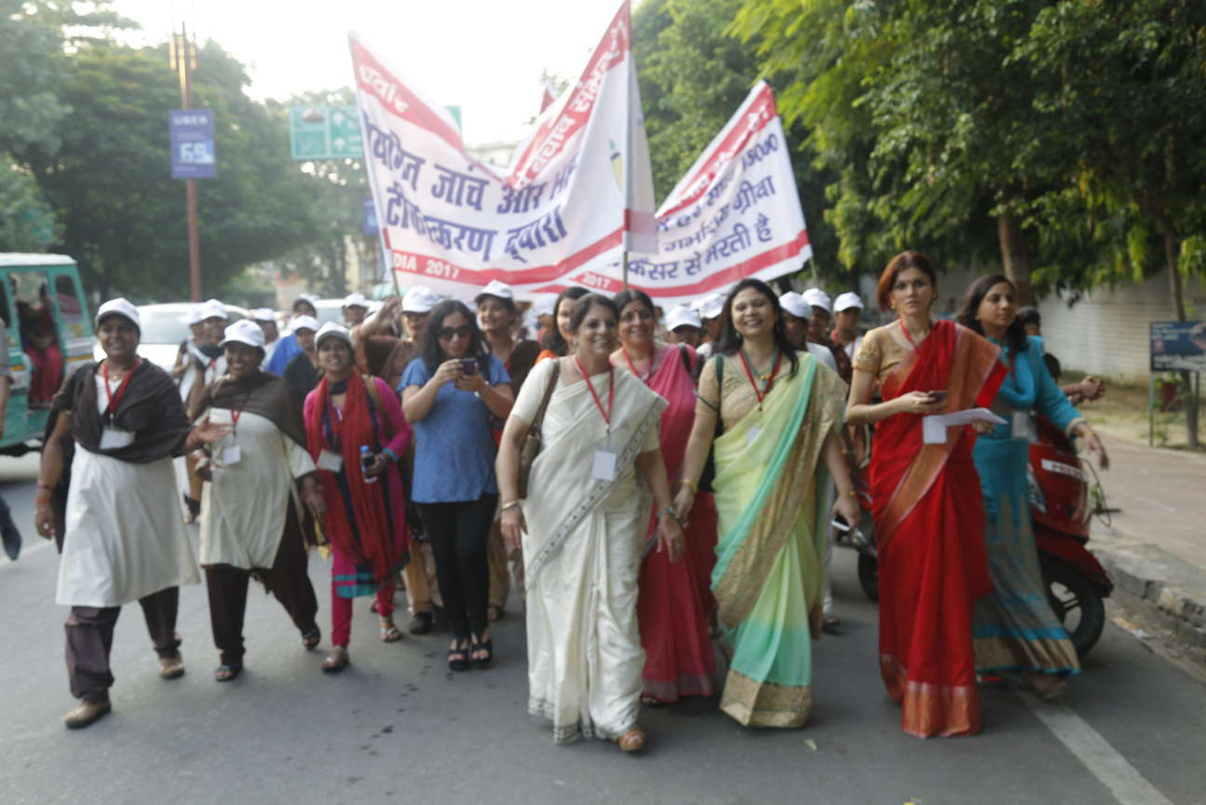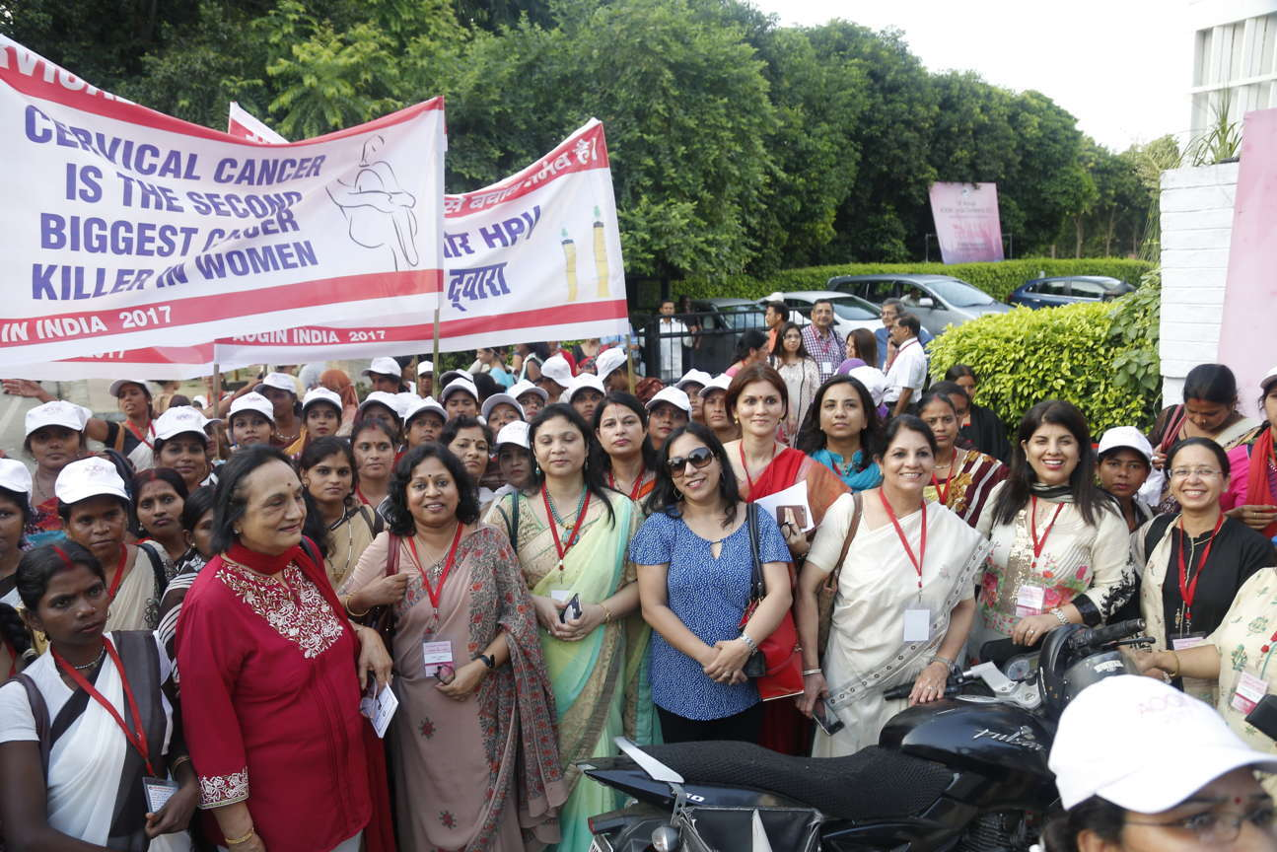

**9th September 2017 hall 1 (9:00 am-5:00 pm)**

The first session was dedicated to “Oncogenic HPV , infection leads to cancer”. It was chaired by **Dr. Theresa Wang Freeman** from UK and Dr. Veena Acharya. The AOGIN India vice president **Dr. Abraham Peedacayil** presented a talk on “Pathogenesis of HPV related Genital cancers. Role of HPV biomarkers in screening paradigms was explored in an enlightening talk by Dr. Shalini Rajaram.

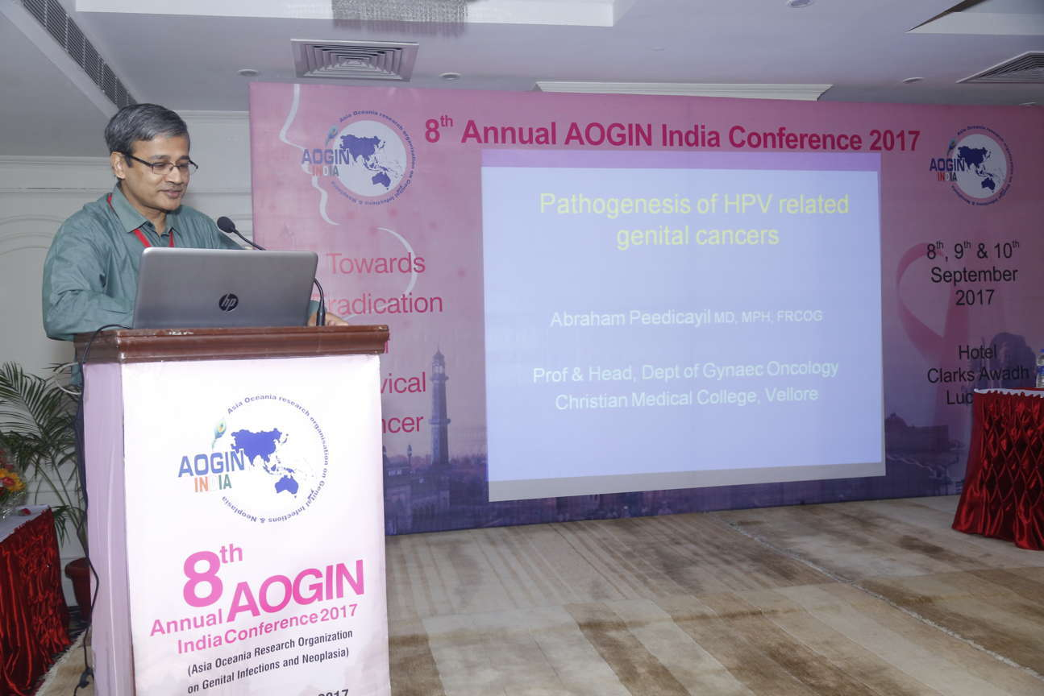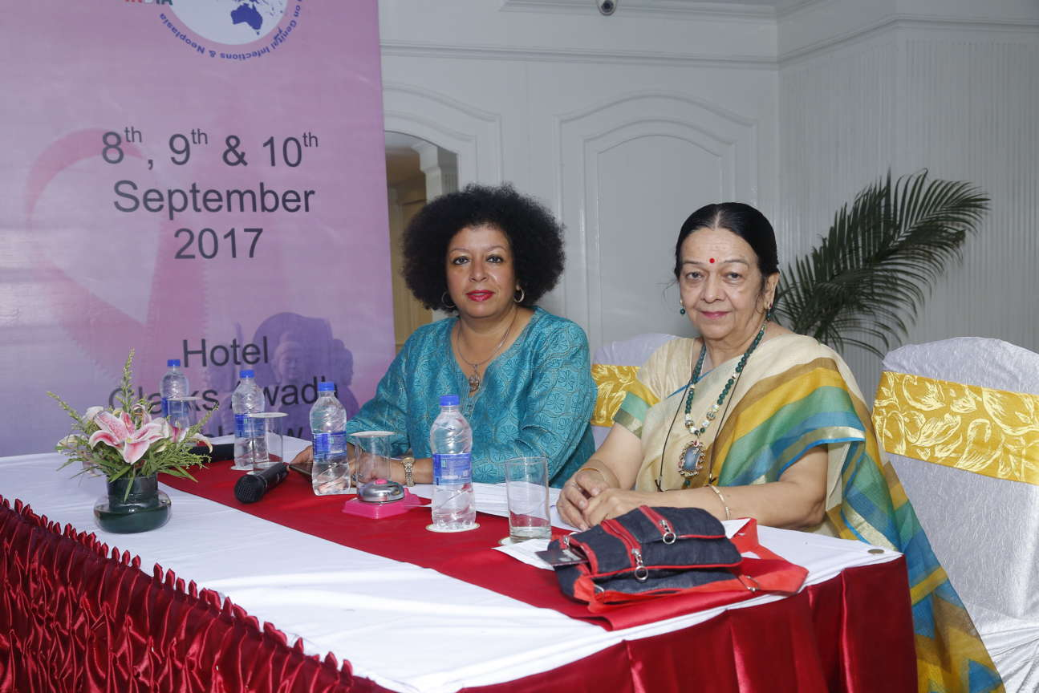 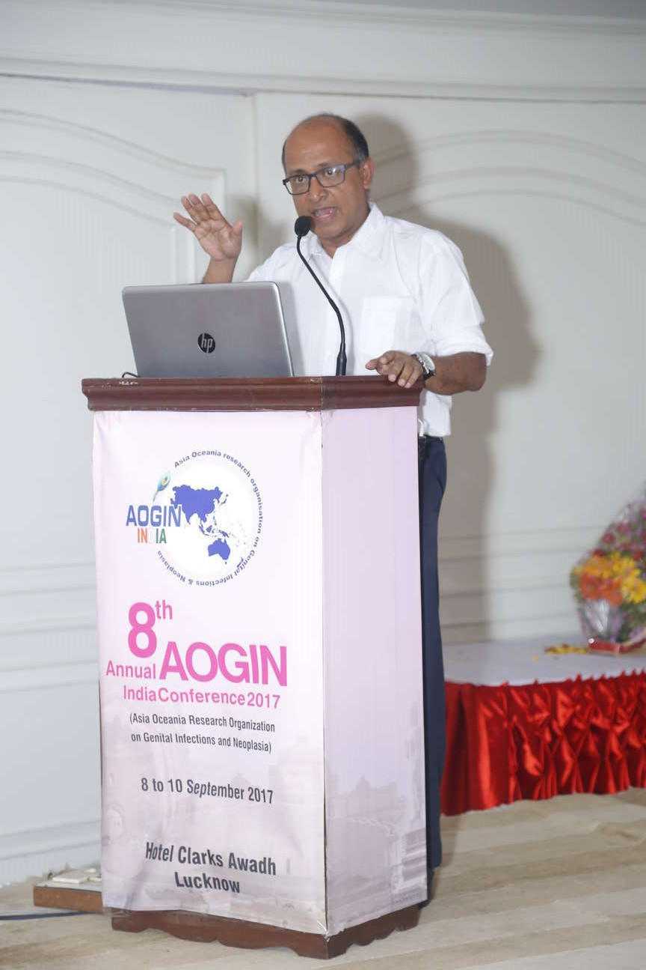

Session II dealt with the nuances of “Screening of cervical cancer”. The esteemed chairpersons were Dr. Usha Saraiya , Dr. J.K Singh and Dr. H. P. Gupta. **Dr. Enriquito Lu. From JHPIEGO gave an** insight into the “Data use for improving screening outcomes with access of effective treatment . “Changing Paradigm for cervical cancer screening (newer methods)” was the second talk in which Dr. **Theresa Freeman Wang** enlightened the audience on the future of colposcopy that would be cheaper, smaller, lighter , with smartphone attachments and perhaps include other intrinsic tissue properties. **Dr. Bhagyalaxmi Naik** shed light on “Communicating risk and Psychosocial effects of screening” in a lucid presentation.

After these lively talks the session was concluded with a dynamic **Debate over “What is the best screening tool for India HPV or VIA ?** Dr. Saritha Shamsunder advocated that HPV DNA screening should be the best tool while Dr. Bindiya Gupta countered the argument by presenting the reasons why VIA is the cost effective screening tool for Indian set up . It was concluded that VIA is the best choice untill we hav eresources for HPV testing for all.

Session III was dedicated to “Preinvasive lesions of Cervix”. Chairpersons for this session were Dr. Mona Saraiya, Dr. Geeta Kinara and Dr.Chandrawati. **Dr. Partha Basu** spoke on “Screening is only the first step; Management is the goal” emphasising that without availability of treatment options screening loses its purpose hence bringing into focus the real goal of screening for cancer cervix. The session concluded with **Dr. Ranajit Mandal’s** talk on Newer devices for CIN treatment . The focus was on devices that make ‘screen and treat’ more feasible mainly new thermal and battery operated cold coagulators.

The celebration of the day was the “**Lifetime achievement award ceremony for Dr. Usha Saraiya”**, a legendary gynaecologist who has contributed singnificantly to the field of cervical cancer prevention and treatment.. A shawl, plaque and citation were presented to her by Dr Neerja Bhatla, Dr Shalini Rajaram, Dr HP Gupta and Dr Nisha Singh. She graced the ceremony and blessed the audience with her words of wisdom.

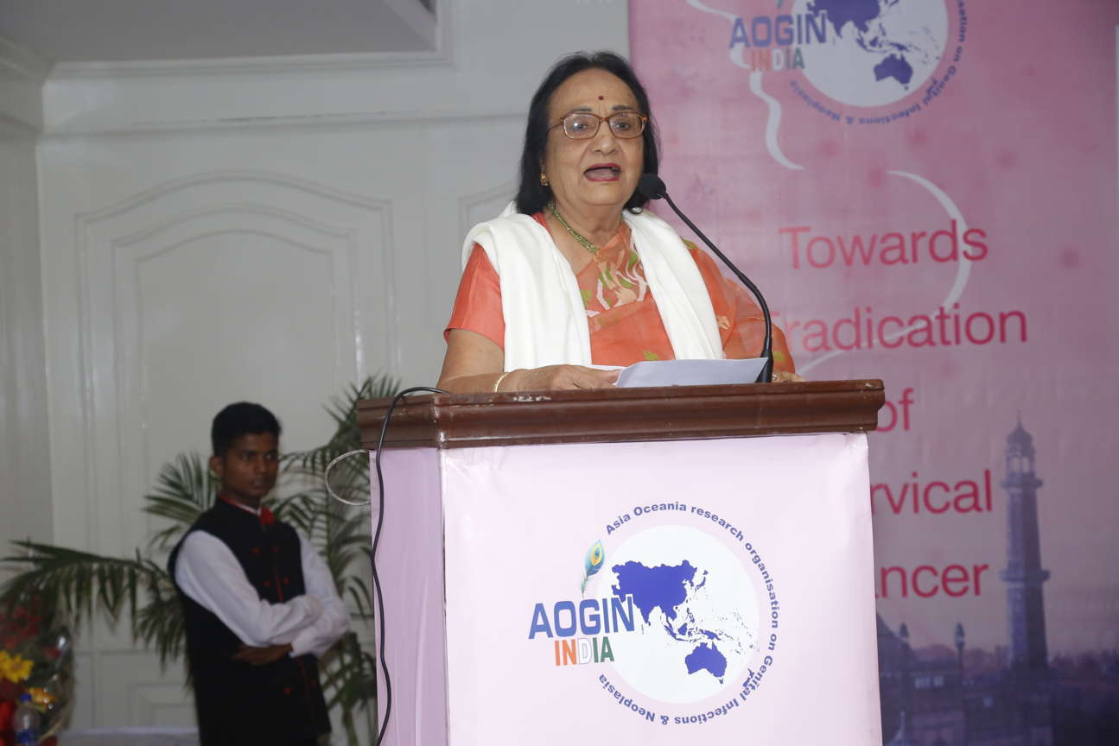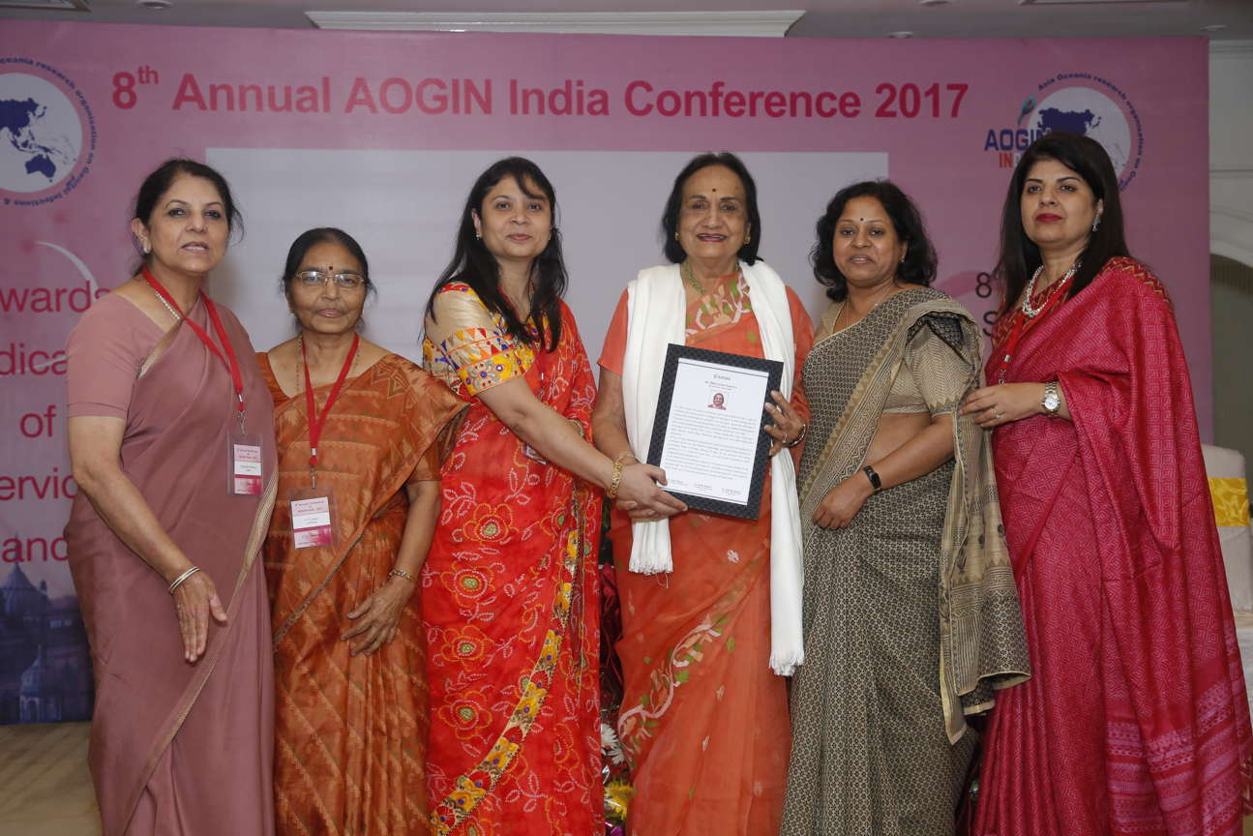

All the International guest faculty members including Dr Suzanne Garland (Australia), Dr Adeola Olaitan (England), Dr Theresa Freeman Wang (UK), Dr R. Shankarnarayan (France), Dr Partha Basu (France), Dr Ashrafunnessa (Bangladesh), Dr. Niharika Khanna (USA), Dr Rokeya Anwar (Bangladesh), Dr Mona Saraiya (USA) and Dr Saunthari Somasundaram (Malaysia) were also felicitated at the same time to honor them in the India way.

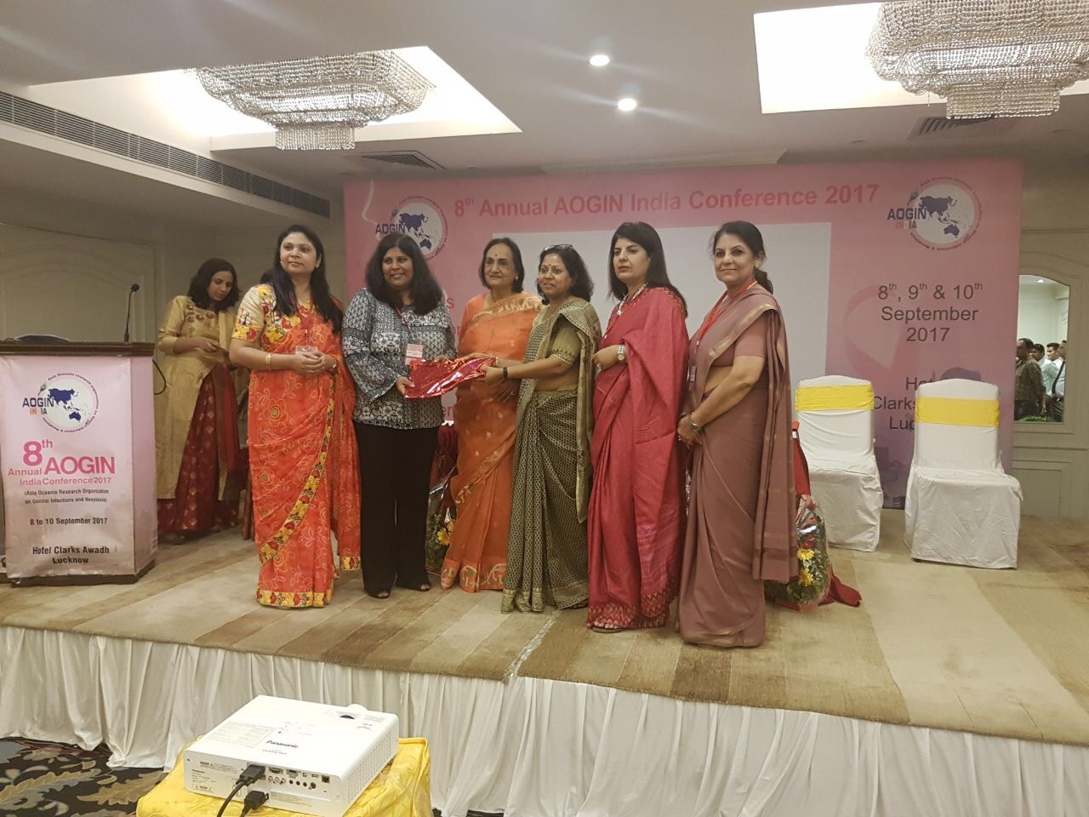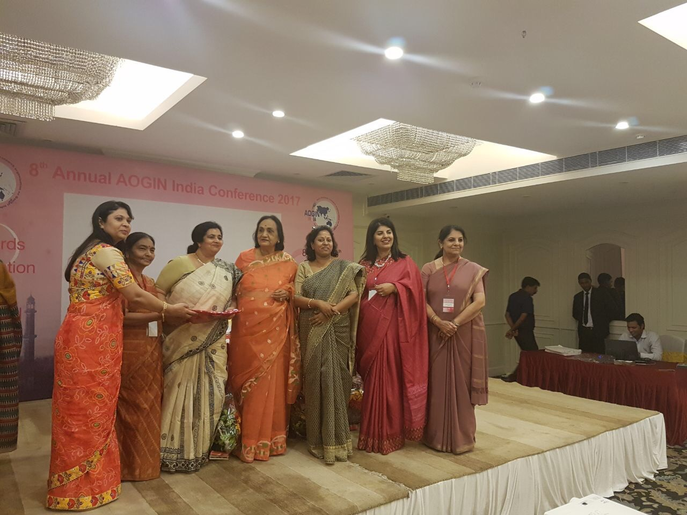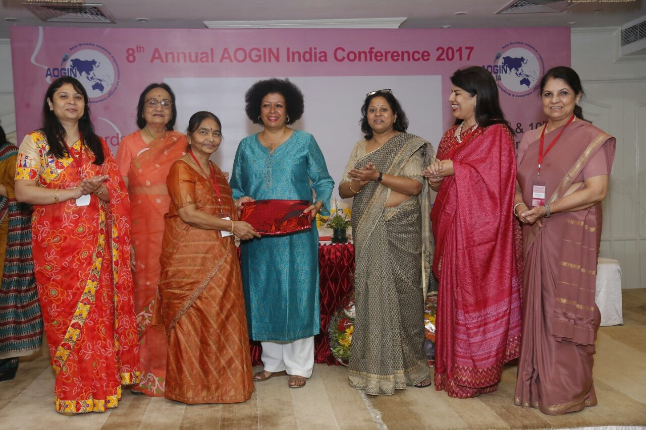

Session IV got the audience busy with an amazingly vibrant **Panel discussion on Management of abnormal screening tests**; moderated by **Dr. Rupinder Sekhon and Dr. Bindiya Gupta** the Panelist: Dr. Rokeya Anwar , Dr. Kiran Pandey , Dr. S P Jaiswar, Dr. Vasundhara Kamaneni gave insights into management options in various case scenarios.

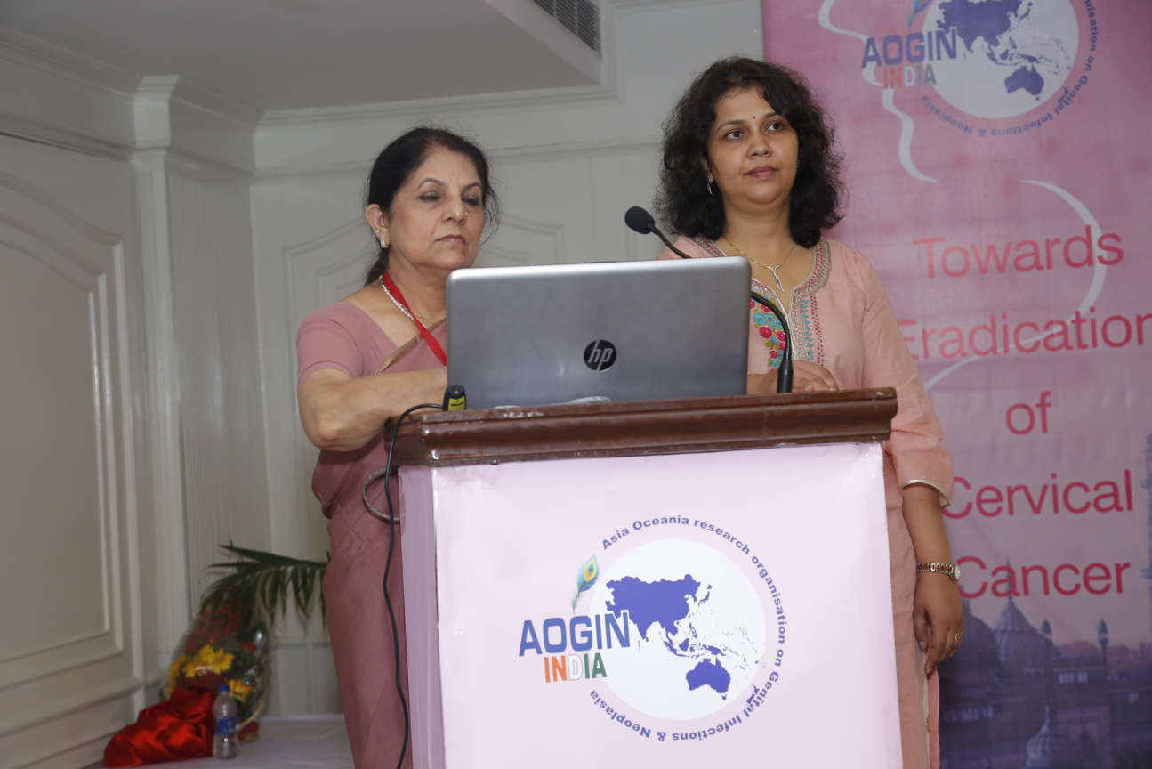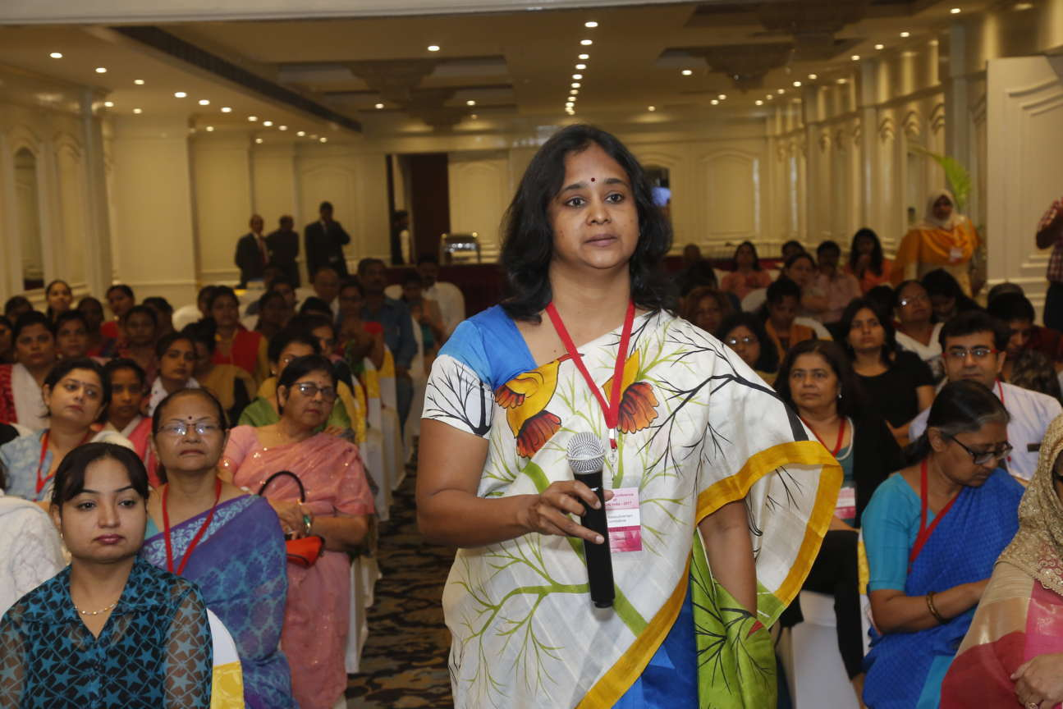

Session V brought in the age old wisdom of “Prevention is better than cure “. The session was chaired by Dr. Niharika Khanna , Dr. Nisha Singh and Dr. Anju Rani . “Current status of HPV Vaccination around the globe”- **Dr. R. Sankarnarayanan** shared his valuable experience over this topic sharing the practices in various countries all over the world . The bivalent and Quadrivalent HPV vaccines were detailed in a crisp presentation by **Dr. Shakti Bhan Khanna** . She talked about the mechanism of action, recommendations and dosage schedule for the vaccines. **Dr Neerja Bhatla** closed the session with her talk on “What’s new in the HPV vaccine basket”. She brought forth data that supports two dose regime for young girls, the possibility of one dose regime and about nonavalent vaccine. The day ended with yet another **Debate on Digital devices are the future of colposcopy**. Dr. Shweta Giri spoke for the motion and Dr. Mamta Dagar presented her views against the motion.

**9th September 2017 Hall 2 (9:00am-5:00pm)**

The first set of Oral Paper Presentations were judged by **Dr Adeola Olaitan** and Dr Rupinder Sekhon. Another set of Oral Papers was judged by **Dr R. Sankarnaraynan from IARC** and AOGIN India president Dr Shalini Rajaram. Poster Prsentation was judged by **Dr Suzanne Garland from Australia and Dr Partha Basu from IARC.**

**Total of 17 research paper abstracts and 25 Poster abstracts were accepted** for presentation out of which **12 papers and 20 posters were presented** by respective authors in the conference.

Session on “Expanding the scope of Gynaecologist was chaired by Dr Rukhsana Khan and Dr Yashodhra Pradeep. **Dr. Bulbul Sood from JHPIEGO** presented a talk on “Comprehensive cervical cancer control in low resources setting-Lesson learnt”. Dr Anshul Grover talked about on “Screening for breast cancer and Dr Arshad Ahmad on “Screening for Anal Neoplasoia”.

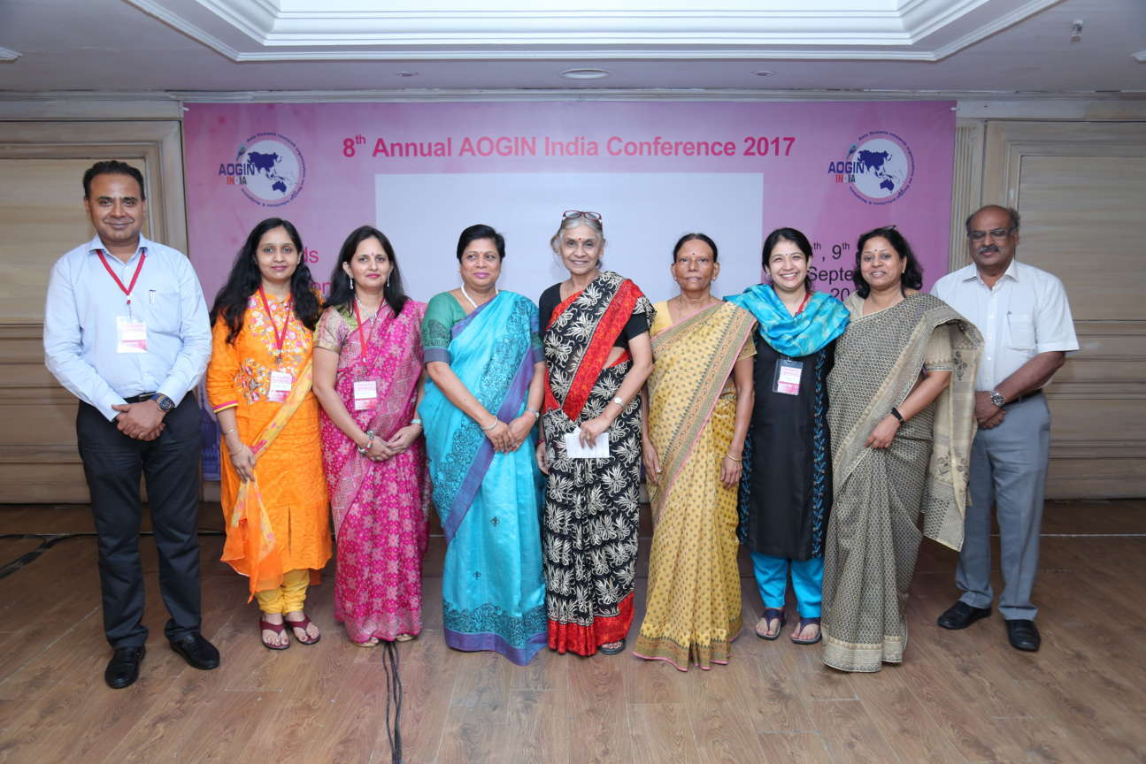

The Session on “Cervical Cancer Control in India States” was was chaired by Dr Hemali H Sinha, Dr Uma Singh and Dr A.N. Srivastava. Dr Lata Balasubramani presented the first talk Tamil Nadu. Dr Amresh Singh from NHM Uttar Pradesh appraised about the progress in cervical cancer control in our state with the help of Sampoorna Clinics and publicprivate partnerships. Dr Sharmila Pimple presented the report from the state on Maharashtra. After this session many tips and ticks for management of Vulvo Vaginal Carcinoma were given by Dr.S. K. Giri. The Industry Sponsored by Roche included a talk on “Cervical cancer Diagnostis” by Dr Sandeep Sewilker. The day ended with AOGIN India Executive Meeting and GBM where new office bearers were announced.

**Glimpses of the cultural evening**

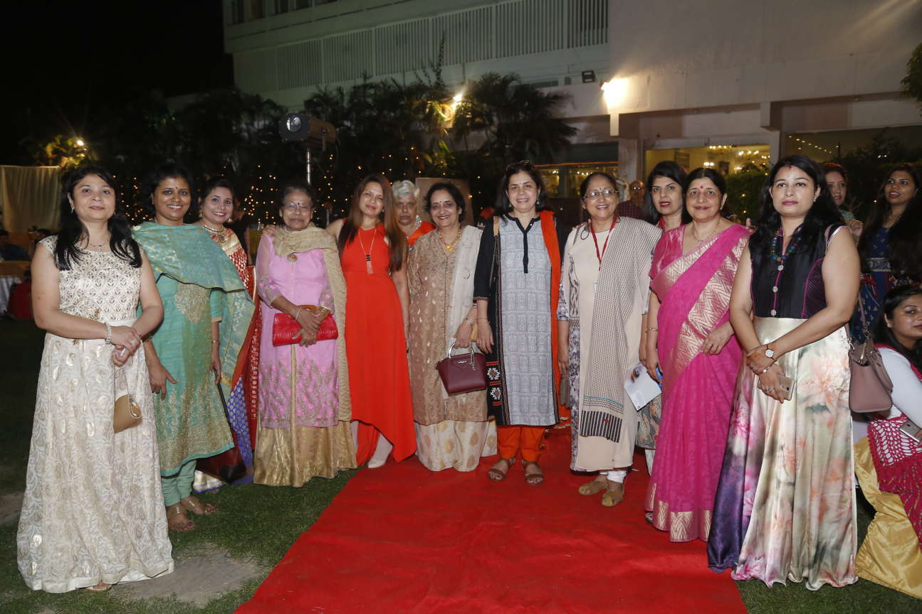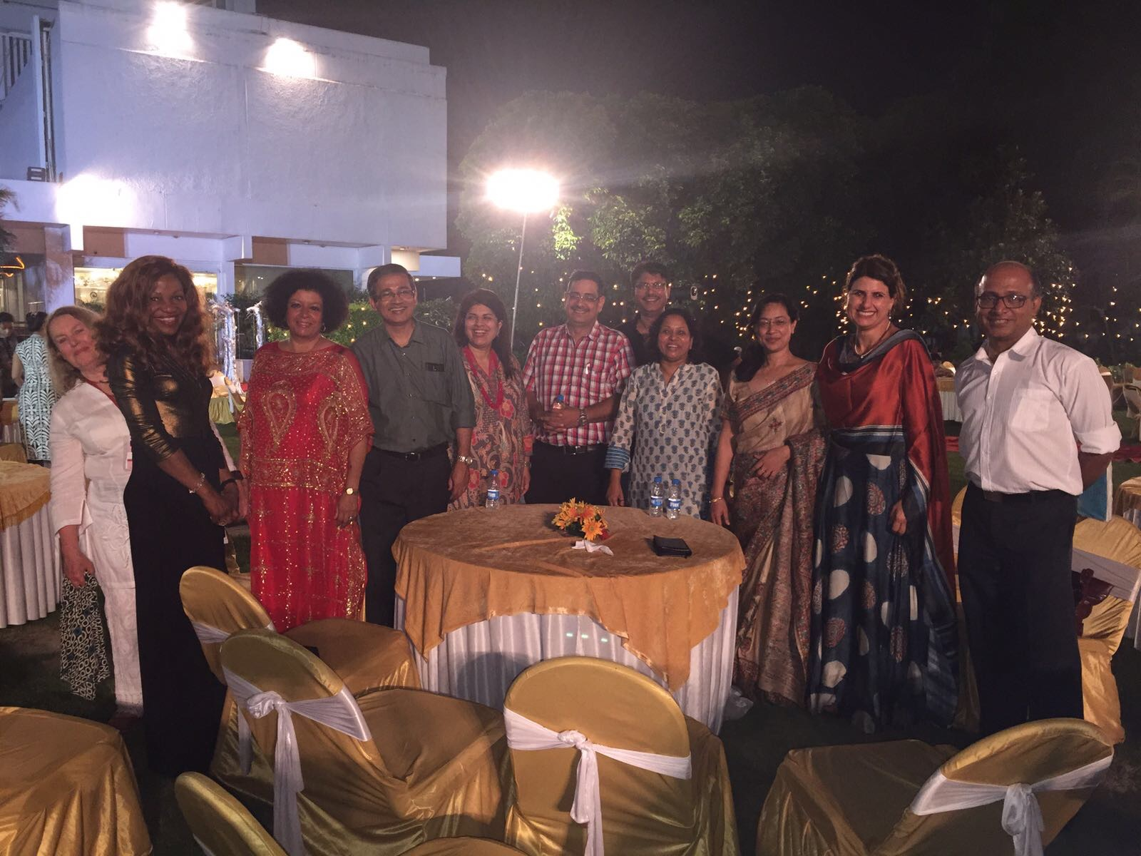

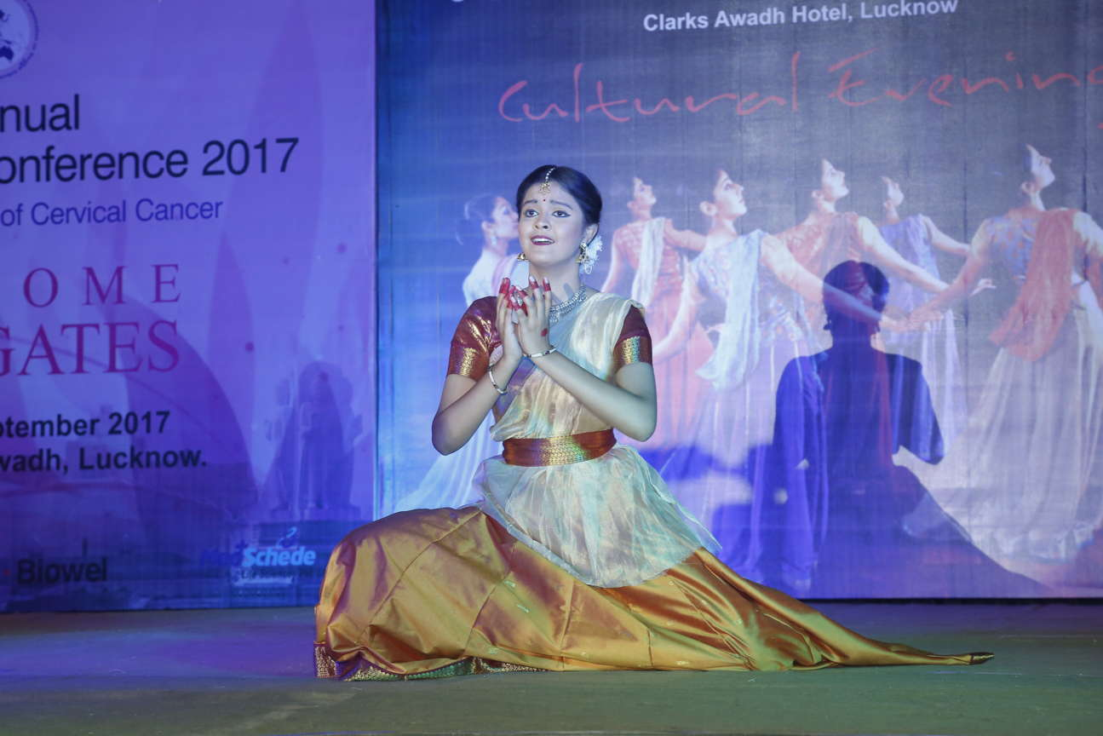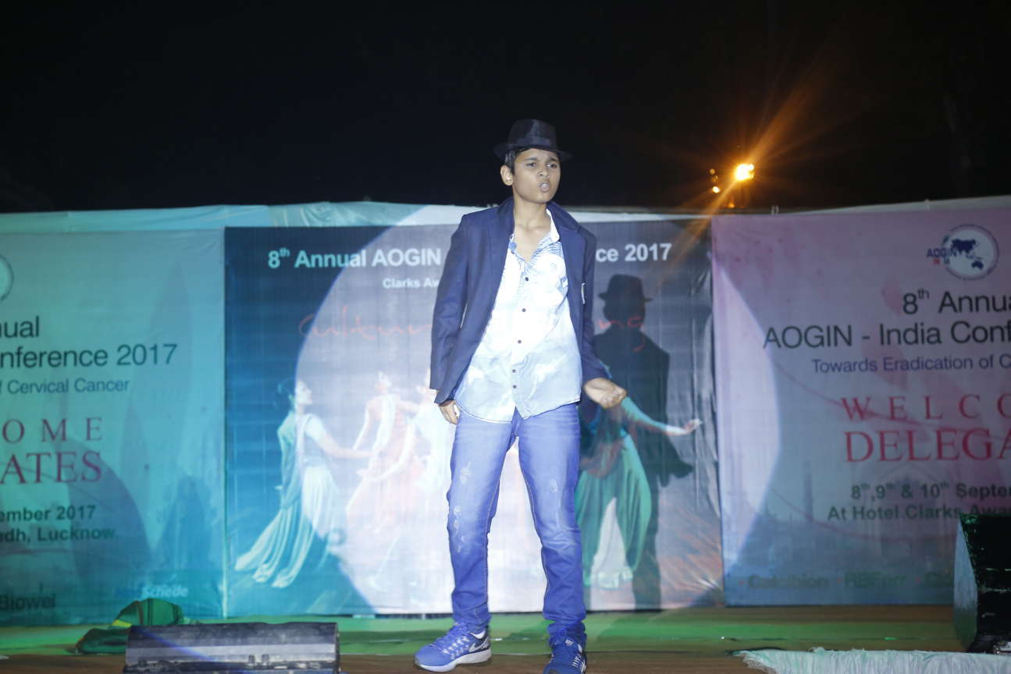

**10th September 2017 Hall 1 (9:00 am -2:00 pm)**

The First session on “Cervical Cancer control around the globe” was chaired by Dr.Ashrafunnessa from Bangladesh presented “Recent Changes in cervical cancer Screening Program in Bangladesh where she highlighted the successful excution of VIA program in her country. Dr Saunthari Soma Sundaram from Malaysia discussed the Cervical cancer control in Malaysia. The second session on “Role of International Organizations’ was chaired by **Dr R. Sankarnaraynan from IARC**, Dr S. P. Jaiwasr and Dr Renu Singh. **Dr Niharika Khanna from USA** talked about HPV vaccines implementation in the the state of Maryland in United States. **Dr Mona Saraiya** was a representative from **CDC, USA**. She talked about Cervical Cancer Screening redlines in India – CDC report. The Keynote address was delivered by **Dr Suzanne Garland from Australia** on “10 years of quadrivalent vaccines in Australia”

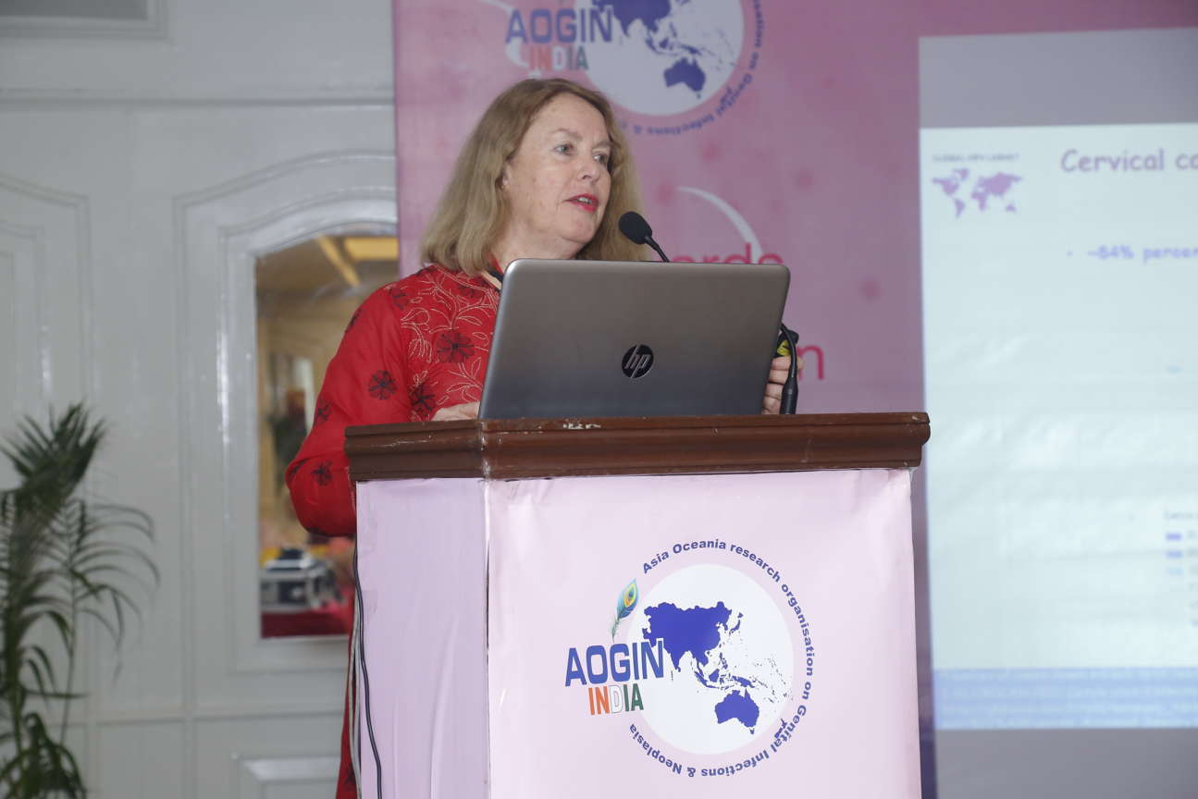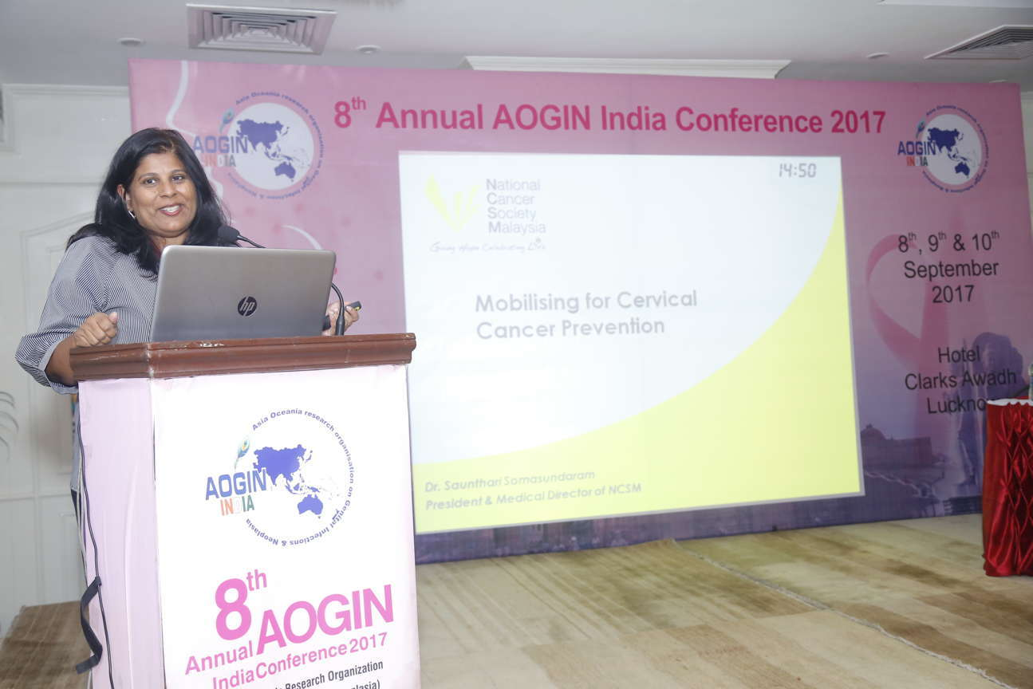

The **Public Forum on “Knowledge, Attitude and Practice about cancer in Indian Women”** was moderate by the organizing secretary, Dr Nisha Singh and experts were Dr Neerja Bhatla, Dr Shalini Rajaram, Dr Usha Sariya and Dr H. P. Gupta. It was attended by 150 representatives from public including students, teachers, NGOs and media personnel. Ms Aparajita from AIR FM helped the public ask a variety of questions and the experts gave detailed explanations to all of them. The forum sent clear messages about need, benefits, freqency and dosage schedule of HPV vaccination and cervical cancer screening. The availabilty of these facilities in the city was also discussed about.

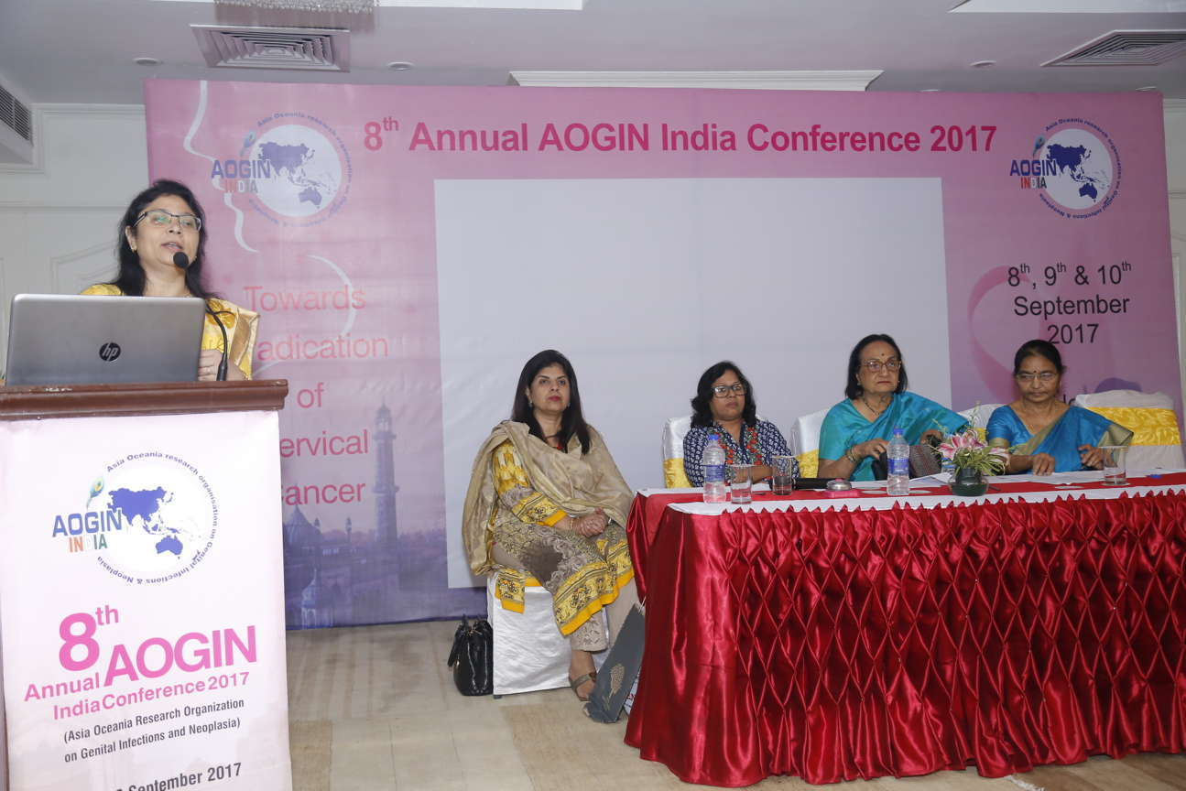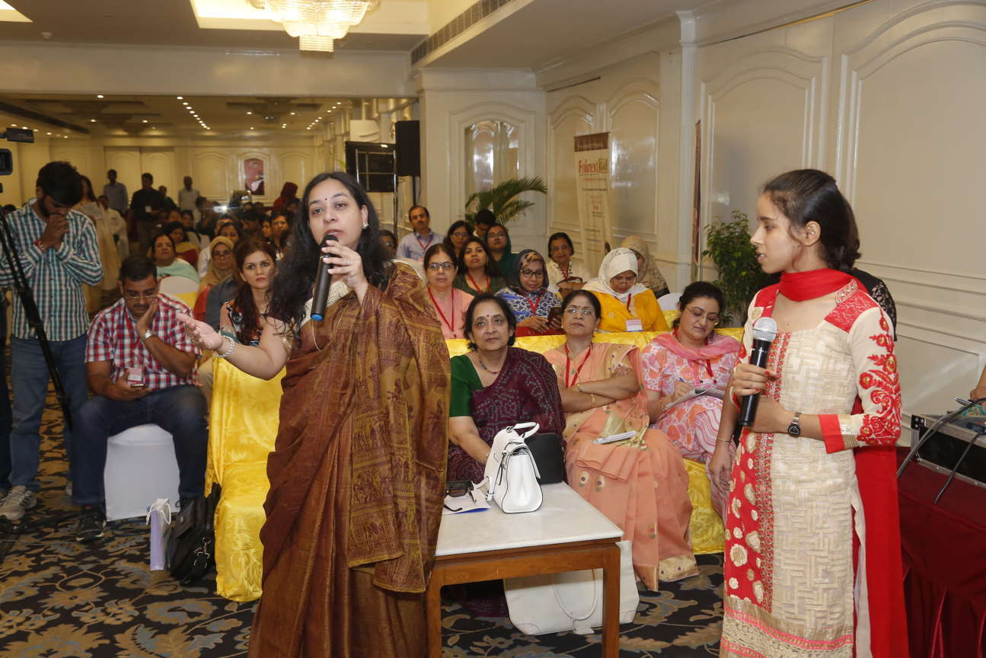

The Panel discussion on **Fertility sparing treatment of cervical cancer** was moderate by Dr Lalta Balasubramani with Dr Adeola Olaitan (UK), Dr Sabhyata Gupta, Dr Uma Singh and Dr Anju Rani as the panellists.

The session on Special Situation was chaired by Dr Rokeya Anwar, Dr Urnila Singh and Dr Manjusha. Dr Richa Singh talked about the less touched topic of “Palliative Care – The road beyond treatment”. Dr Nisha Singh discussed about “Screening and Diagnosis of Cervical Cancer in HIV positive women.

The conference was concluded with the **Valedictory function** conducted by the AOGIN India president Dr Shalini Rajaram and the Organizing team. The best research paper prizes were given to Dr Amit Mandal (1st Prize) from Kolkata, Dr Lutfa Begum Lipi (2nd Prize) from Bangladesh and Dr Ruchi Pathak (2nd prize) from Varanasi. The best poster prizes were given to Dr Loukya (1st Prize) from New Delhi and Dr. Vasundhara Kamineni (2nd Prize) from Telangana.

